SECTION 27 1000
STRUCTURED CABLING
*************************************************************************************************************
LANL MASTER SPECIFICATION
This template must be edited for each project. In doing so, specifier must add job-specific requirements. Brackets are used in the text to indicate designer choices or locations where text must be supplied by the designer. Once the choice is made or text supplied, remove the brackets. The specifications must also be edited to delete specification requirements for processes, items, or designs that are not included in the project - and specifiers’ notes such as these. Additional tailoring requirements are contained in ESM Chapter 1 Section Z10 Att. F, Specifications.

To seek a variance from requirements in the specifications that are applicable, contact the Engineering Standards Manual Communications POC. Please contact POC with suggestions for improvement as well.
When assembling a specification package, include applicable specifications from all Divisions, especially Division 1, General Requirements.
Specification developed for ML-4 projects. For ML-1, 2, and 3 applications, additional requirements and independent reviews should be added if increased confidence in procurement or execution is desired; see ESM Chapter 1 Section Z10 Specifications and Quality sections.
*************************************************************************************************************
- GENERAL
  - SECTION INCLUDES
    - Telecommunications pathways including conduit, raceway and cable tray systems including:
      - Installation of telecommunications backbone cables.
      - Installation, termination, and testing of horizontal cables and outlets.
      - Telecommunications terminal boards.
  - LANL-FURNISHED EQUIPMENT FOR project-installed cabling system (GFE)
    - Category 6A unshielded twisted pair (UTP) horizontal cable shall be used to connect telecommunications outlets to all new buildings.
    - Any new temporary building which will be located on LANL property with a usage expectancy of less than 10 years shall utilize a Category 5E horizontal cabling system. Building remodels and retrofits will utilize, at a minimum, a Category 5e horizontal cabling system. Category 6A will be used if :
      - The building already has Cat 6A installed.
      - If 50% or more of a building is being remodeled or renovated.
      - If future networking needs require a 6A horizontal cabling solution.

Confer with LANL Communications Group SMEs for any specific installation requirement that may arise.
    - Telecommunications outlet/connectors.
    - Telecommunications backbone cables.
    - [Television outlets and connectors.]
  - LANL FURNISHED AND INSTALLED EQUIPMENT
    - Telecommunications entrance cable.
    - Cross-connect equipment.
    - Telecommunications systems electronics equipment.
    - Television system electronics equipment.
  - LANL PERFORMED WORK
    - LANL will terminate telecommunications backbone cables.
    - Structure/structural inspection and acceptance prior to the placement of any Category 5E or 6A UTP cables, and then inspection of the placement and terminations of all Category 5E or 6A UTP cables. Face plates must remain off outlets until physical inspections of terminations have been completed by LANL Telecommunications Group.
  - ACTION SUBMITTALS
    - Prior to commencement of applicable scope(s) of work, submit required qualifying certifications of cable installer(s) as described in Article 1.7 of this Section unless on file with LANL Telecommunications Group.
    - Test reports in a Fluke Linkware format for each installed and terminated fiber and Category 5E or 6A UTP horizontal cable.
      - LANL Telecommunications Group will review the electronic test results on all Category 5E or 6A UTP and fiber cables for conformance. Cables must meet all testing requirements before cable is accepted.
  - CLOSEOUT SUBMITTALS
    - Detailed redlines of structure and cable routing submitted to the LANL Telecommunications Group upon completion of applicable scope(s) of work.
    - Conform to the requirements of the National Fire Protection Association (NFPA-70).
    - Category 5E UTP cable installers shall have the following minimum qualifications with current certifications:
- Registered BICSI ITS Installer 2 copper.
    - Category 6A UTP cable installers shall have the following minimum qualifications with current certifications:
      - Registered BICSI ITS Installer 2 copper, and Certified Systimax installer or directly supervised by a certified Systimax installer.
    - Optical fiber installers shall have the following minimum qualifications with current certifications:
      - BISCI Installer 2 Optical Fiber
  - COORDINATION
    - Coordinate all telecommunications service(s), interior distribution, and submit a 30-60-90% design drawing review to the LANL Telecommunications Group.
    - Coordinate installer training and cable termination tool requirements for horizontal cabling installers with the LANL Telecommunications Group.
    - Order horizontal cabling and outlet/connectors from the LANL Telecommunications Group based on actual count, measurement of conduit and cable tray runs, and required cable slack. Place order not less than 10 working days prior to scheduled start of installation.
    - Schedule installation of horizontal cabling and outlet/connectors to start after the completion of application of finishes to walls and after the completion of the telecommunications room(s) to minimize potential for damage to cables. Notify the LANL Telecommunications Group of the placement schedule for inspections.
- Products
  - CONDUIT
    - Provide conduits for service, backbone, and horizontal cables as indicated on the drawings or as required for a complete telecommunications pathway system.
    - Contact the LANL Telecommunications Group Quality Assurance Inspector to schedule a structure/structural inspection before cabling is placed.
    - Select sizes of conduit for horizontal cables on the following basis:
      - Nominal cable diameter: 0.285 inches for Cat6A or 0.195 for Cat5E.
      - Minimum conduit size: 1-inch unless specified otherwise.
      - Number of Category 6A cables per conduit: 3 cables per workstation outlet unless noted otherwise on the Drawings.

Required Conduit Sizes per Outlet for Distance/Bend Situation (Cat 6A cable)
 |  | Less than 50 ft. between pulling points and only one bend  (40% fill allowed) | More than 50 ft. between pulling points or two  90-degree bends  (31% fill allowed)
Cables per Outlet | Three (3) | 1” | 1-1/4”
 | Four (4) | 1-1/4” | 1-1/2”
    - Refer to Section 26 0533, Raceways and Boxes for Electrical Systems.
  - Raceway MEASURING TAPE
    - Refer to Section 26 0533, Raceways and Boxes for Electrical Systems.
  - SURFACE METAL RACEWAY
    - Refer to Section 26 0533, Raceways and Boxes for Electrical Systems.
  - CABLE TRAY
    - Provide cable tray system for backbone cables and horizontal cables as indicated on the Drawings or as required for a complete telecommunications pathway system.
    - Provide ladder type cable tray with maximum 6-inch rung spacing.
    - Select cable tray sizes for horizontal cables based on the larger of:
      - One (1) sq. in. of cable tray per 100 sq. ft. of useable floor area served, or
      - Fill ratio of 41.6 percent.
    - Refer to Section 26 0536, Cable Trays for Electrical Systems.
  - OUTLET BOXES
    - Refer to Section 26 0533, Raceways and Boxes for Electrical Systems.
    - Use 4-11/16 inch square, 2-1/8 inch deep outlet boxes with single gang raised device covers for telecommunications and television outlets served by 1 inch or smaller conduit.
    - Use 5 inch square, 2.875 inch deep outlet boxes with single gang raised device covers for telecommunications and television outlets served by conduits 1-1/4" or larger.
  - PULL AND Junction BOXES
    - Provide pull and splice junction boxes with the following minimum dimensions: Three times the trade size diameter of the largest conduit in addition to the sum of the remaining conduits.
- For a conduit entering the wall of a pull box opposite to a removable cover, have a distance from the wall to the cover of not less than the trade-size diameter of the largest conduit plus three times the diameter of the largest conduit.
  - TERMINAL BOARDS
    - Use 3/4 inch thick APA grade A-B interior plywood without voids.
    - Paint front, back, and all edges with two coats of white or light gray, intumescent latex, fire-retardant paint with a Class A fire rating.
  - GROUNDING
    - Provide a ground bar for each terminal board.
      - Furnish 12 inch x 4 inch x 1/4-inch copper ground bar with 1-inch standoff insulators.
      - Drill ground bar with 7/16-inch bolt holes at (1 and 3/4) x 2 inch NEMA spacing for two-hole irreversible compression lugs.
    - Refer to Section 26 0526, Grounding and Bonding for Electrical Systems, for additional requirements.
  - CATEGORY 5E and 6A UTP CABLEs (LANL-FURNISHED)
    - Cable is UL listed as type CMP for use in ducts, plenums and air handling spaces.
    - A typical network port consists of three Belden Cat5E or Systimax Cat6A unshielded twisted pair cables.
    - Manufacturers/Models: Belden Cat5E 1701A; Systimax Cat6A GigaSpeed X10D 2091B
  - Backbone Cable (LANL-Furnished)
    - Copper backbone cable is ARMM cable, 24 AWG, UL listed as type CMR.
    - Fiber optic backbone cable is UL listed as type OFNP or OFNR, tight-buffered cable with a mixture of single-mode and multi-mode fibers.
  - TELECOMMUNICATIONS OUTLET/CONNECTORS (LANL-FURNISHED)
    - Each GFE telecommunications outlet will consist of a plastic faceplate with three 568B configured RJ45 modular connectors with one blank.
    - Cable connections are made to insulation-displacing-type (IDC) connectors using an approved punch down tool.
    - Manufacturers: Belden and Systimax
  - CROSS-CONNECT EQUIPMENT (LANL-FURNISHED)
    - The GFE will consist of Systimax X10D VisiPatch360 termination blocks. The quantity of blocks provided will be sufficient for the standard two-connection model work area channel.
    - Horizontal cable connections are made to insulation-displacing-type (IDC) connectors using an approved punch down tool.
    - Manufacturer: Systimax X10D
- Execution
  - EXISTING WORK
    - Remove exposed telecommunications cables, including abandoned cables above accessible ceiling finish. Patch surfaces where removed cables passed through building finishes.
    - Refer to Section 26 0533 for removal of abandoned telecommunication raceways and boxes.
    - Provide access to existing telecommunications cable connections remaining active and requiring access. Modify installation or install access panel.
  - EXAMINATION
    - Verify interior of building has been protected from weather.
    - Verify mechanical work likely to damage telecommunications cables has been completed.
    - Verify telecommunications pathway installation is complete and supported.
    - Verify that installation of telecommunications rooms is complete.
    - Examine raceways and building finishes receiving telecommunications cables for compliance with installation tolerances and other conditions. Do not proceed with installation until unsatisfactory conditions have been corrected.
  - GENERAL
    - Install telecommunications system according to NFPA-70 Articles 770 and 800, and requirements in this Section.
    - Maintain separations between telecommunications pathways and sources of electromagnetic interference.
  - Cable Tray Installation
    - Install cable tray around the perimeter of each telecommunications room and above the equipment racks.
      - Locate cable tray with edge 8 inches from perimeter walls.
      - Provide six cable tray dropout fittings in each telecommunications room. Install cable tray dropout fittings at locations directed by the LANL Telecommunications Group.
      - Extend cable tray to each open telecommunications equipment rack.
    - Install vertical cable tray in telecommunications room(s) to support backbone cables rising to upper floors.
    - Install cable tray system to distribute horizontal cables from the telecommunications room(s) to locations near the telecommunications outlets. Locate cable tray concealed above corridor lift-out ceilings. Connect to the cable tray in the telecommunications room(s).
    - Install cable tray at least 6 inches away from fluorescent or HID lighting fixtures to help mitigate electromagnetic interference.
    - Install cable tray so there will be not less than 12 inches above and to the side of tray to permit access for installing and maintaining cables. Locate cable trays below suspended mechanical equipment, piping, and ductwork that would impede access to the cable tray.
    - Refer to Section 26 0536, Cable Trays for Electrical Systems, for additional installation requirements.
  - CONDUIT INSTALLATION
    - Install the telecommunications service entrance conduits as indicated on the Drawings. Turn up the telecommunications conduits at the left rear corner of the telecommunications room adjacent to the left wall. Seal the building end of entrance conduits to prevent rodents, water, or gasses from entering the building.
    - Install conduits for backbone cables between telecommunications rooms.
      - Install two 4 inch conduits between vertically associated telecommunications rooms.
      - Install two 4 inch conduit between telecommunications rooms on the same floor.
    - Install an individual conduit for telecommunications horizontal cables from each telecommunications outlet to the telecommunications terminal board, raceway or telecommunications cable tray.
    - Install a 1” conduit from the telecommunications room to the elevator controller in the elevator equipment room. Coordinate installation with elevator subcontractor.
    - Install a 1” conduit from the telecommunications room to the fire alarm control panel. Install a 6” x 6” x 4” box adjacent to the fire alarm control panel. Connect box to fire alarm control panel with a 3/4” nipple.
    - Install a 1” conduit from the telecommunications room to the electrical equipment room. Coordinate location with electrical metering equipment installer.
    - Install a 1” conduit from the telecommunications room to the BAS equipment room per design.
    - Install conduit for telecommunications in maximum lengths of 100 ft. between pull points and no more than 180-degrees between pull points. Install a pull box at any reverse bend.
    - Use bends on telecommunications conduits 2 inches trade size and smaller with a minimum inner edge radius 6 times the conduit internal diameter.
    - Use bends on telecommunications conduits larger than 2 inches trade size with a minimum inner edge radius 10 times the conduit internal diameter.
    - Do not use conduit bodies for changes in direction or as pull boxes.
    - Install raceway measuring tape in empty raceways. Leave no less than 12 inches of slack at each end of the tape. Secure each end of tape.
    - Install conduits and sleeves projecting through structural floors with opening 4 inches above the floor.
    - Terminate each metallic telecommunications conduit with either an insulated throat fitting or an insulating bushing.
    - Refer to Section 26 0533, Raceways and Boxes for Electrical Systems for additional installation requirements.
  - OUTLET BOX INSTALLATION
    - Install outlets at locations indicated on the Drawings. Telecommunications outlet locations shown on the Drawings are in approximate locations unless dimensioned. Verify locations before rough-in.
    - Locate each outlet within 36 inches of a suitable receptacle power outlet.
    - Group and align telecommunications outlets and power outlets so a symmetrical appearance results.
    - Refer to Section 26 0533, Raceways and Boxes for Electrical Systems, for additional installation requirements.
  - TERMINAL BOARD INSTALLATION
    - Install pre-painted terminal board lining three walls of each telecommunications room from the floor to 8 ft above the floor.
    - Install terminal boards plumb, and attach securely to the building structure with fasteners at not more than 24" on center vertically and horizontally.
  - GROUNDING INSTALLATION
    - Install a ground bar at lower right corner of the left wall terminal board in each telecommunications room.
    - Connect ground bar(s) to the building main electrode ground bar with 4/0 AWG 600V insulated ground cable. If the building structure is steel, also bond the ground bar to the nearest structural steel using 6 AWG or larger conductor.
    - Terminate 4/0 AWG ground cable in the telecommunications duct bank on the entrance telecommunications room ground bar.
    - Run grounding cables exposed or, if exposed to physical damage, in Schedule 40 PVC conduits. Do not install grounding cables in ferrous metal conduit.
    - Make connections to ground bar(s) and bonded objects using hydraulic compression type two-hole lugs. Clean connectors and connection points prior to fastening.
    - Bond telecommunications cable tray to the ground bar with minimum 6 AWG. Install a 6 AWG grounding conductor in the cable tray; bond conductor to each cable tray section using NRTL listed cable tray ground clamps.
    - Bond all metallic telecommunications raceways to the ground bar per. Bond individual raceways with a 6 AWG conductor. Bond groups of raceways using 6 AWG.
    - Use approved NRTL-listed fittings and minimum 6 AWG bonding jumpers to make telecommunications raceways electrically continuous.
    - Use approved NRTL-listed fittings to bond telecommunications conduits to cable trays.
    - Refer to Section 26 0526, Grounding and Bonding for Electrical Systems, for additional installation requirements.
  - CROSS CONNECT EQUIPMENT INSTALLATION
    - Install the following: Cross connect equipment, entrance and backbone cabling, and cross connect jumpers. (GFE as noted)
  - CABLE INSTALLATION
    - Handle and install horizontal cable according to cable manufacturers’ instructions. Have the manufacturer’s installation instructions available at the construction site.
      - Do not subject horizontal cable to a bending radius of less than 4 times the cable outside diameter.
      - Do not subject horizontal cable to more than 25 lb. pulling tension.
      - Do not kink or excessively twist cable.
      - Do not skin or damage cable sheath or conductor insulation.
    - Obtain cable handling and installation requirements for backbone cable from the LANL Telecommunications Group.
    - Examine raceways to receive cables for compliance with installation tolerances and other conditions. Do not proceed until unsatisfactory conditions have been corrected.
    - Completely and thoroughly swab raceways before installing cable.
    - Clean foreign matter from interior of boxes and conduits before installing cables.
    - Store cable for 24 hours in the installation area ambient temperature before installing.
    - Do not “through-pull” cables at boxes, fittings or cabinets where a change of raceway alignment occurs.
    - Comply with Chapter 8 of the NEC.
    - Install backbone cables between telecommunications closets. Leave 15 feet of slack at each end. LANL will terminate backbone cables.
    - Install Category 5E or 6A UTP horizontal cables from each telecommunications outlet to the telecommunications terminal board or the telecommunications cabinet.
      - Install 3 cables from each 3 port outlet; this will be typical.
      - Leave 15 feet of slack at the cross-connect end and 18 inches of slack at the outlet end.
*************************************************************************************************************
Delete the following articles if there is no television system on the project.
*************************************************************************************************************
    - Install one Category 5E or 6A cable from each monitor (aka TV) outlet to the telecommunications room equipment rack designated by the LANL Telecommunications Group. Leave 8 feet of slack cable at the equipment rack and 18 inches at the outlet end.
    - Terminate horizontal telecommunications cables on telecommunications outlet/connectors in accordance with NECA/BICSI 568, designation T568B, per figure (6-2) “Optional Eight Position Jack Pin/Pair Assignments” reproduced below, using an approved punch-down tool. Leave 8" of slack in cables. Coil cable into outlet box and install faceplate on outlet box.
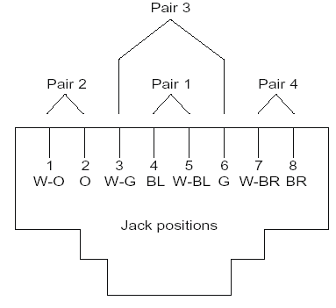
    - Terminate horizontal telecommunications cables on cross connect equipment in accordance with NECA/BICSI 568 and using an approved punch-down tool. Terminate cables in ascending order by room number, cubicle or workstation, and port number as directed by the LANL Telecommunications Group.
  - Identification
    - Uniquely identify each cable and port faceplate, and each fiber housing panel cover in the rack(s). Consult the LANL Telecommunications Group for latest requirements (may differ slightly from the figure below). Provide a tag made with a mechanically produced label with black text on white background.
      - For communication cable, provide label at both ends using a numbering scheme as follows:
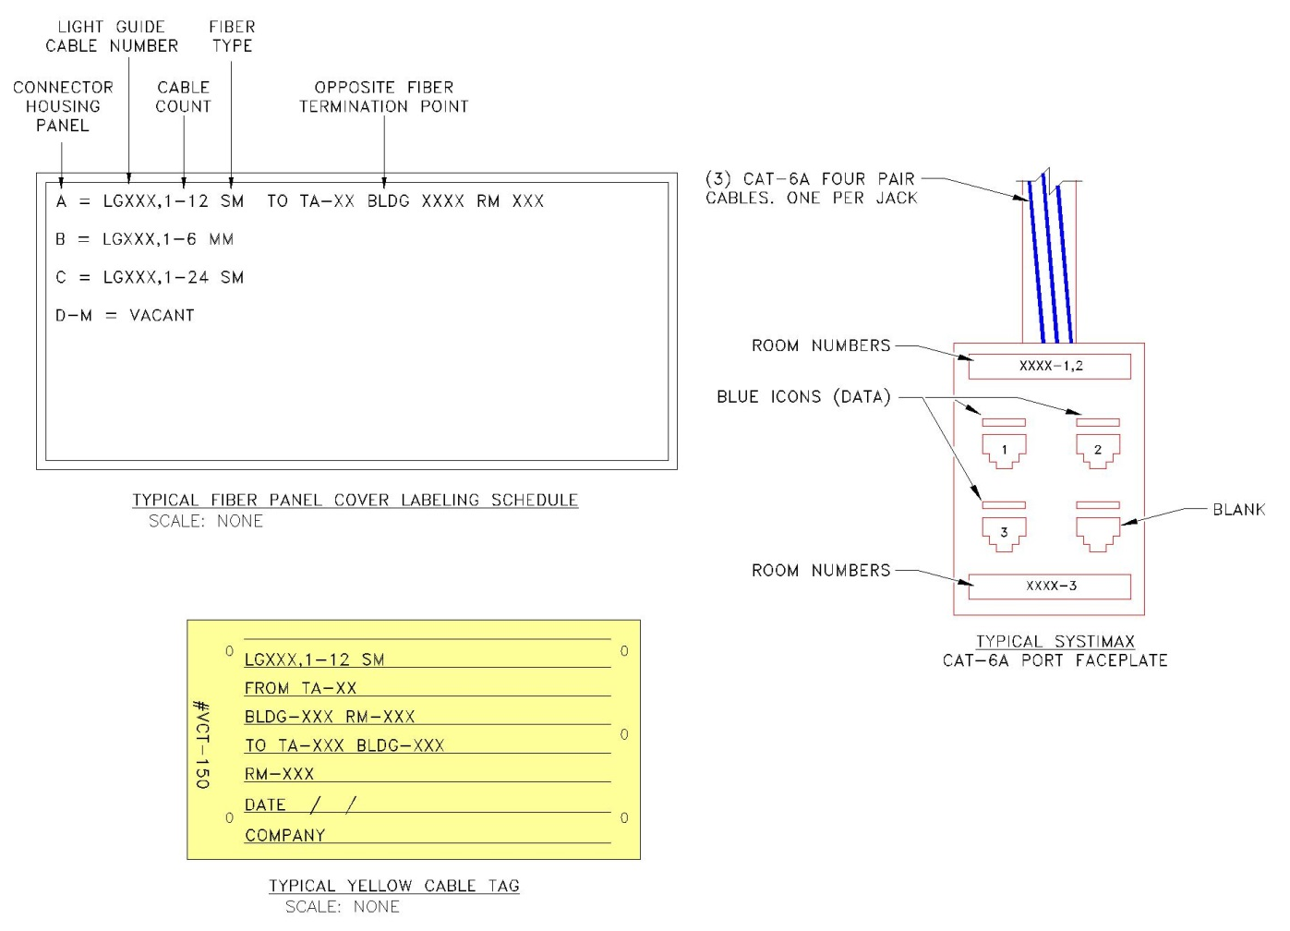

    - Install an identifying label on each conductor connected to the telecommunications ground bar(s). Band both ends of each grounding cable with green plastic tape.
  - ACCEPTANCE TESTING
    - For copper: Perform acceptance test with a DTX Fluke cable analyzer on each installed and terminated Category 5E or 6A UTP horizontal cable per NECA/BICSI 568. Replace cables that do not pass acceptance tests.
      - Provide electronic downloaded records of tests to the LANL Telecommunications Group. LANL will review all test results for conformance.
    - For fiber: Red light all installed fiber optic cable to verify proper polarity. Test using a Fluke optical time domain reflectometer (ODTR).
      - The loss across a multimode fiber connector pair shall not exceed 0.60 db of loss per mated pair total value plus 0.10 db loss per 100 feet of fiber cable length. The loss across a single mode fiber connector pair shall not exceed 0.50 db per mated pair plus 0.03 db loss per 100 feet of fiber cable length
      - If a test results reveal a failure at the splice or otherwise, a second bidirectional Fluke power meter test is required after repair or replacement.
    - Submit all test results in LinkWare format to LANL Telecommunications Group via LANL Subcontract Technical Representative.
END OF SECTION

*****************************************************************************
Do not delete the following reference information:
*****************************************************************************

THE FOLLOWING REFERENCE IS FOR LANL USE ONLY

This project specification is based on LANL Master Specification 27 1000, Rev. 5, dated May 31, 2016.

