7th ANNUAL

RUN FOR HER LIFE

TO FIGHT BREAST CANCER

Los Alamos, New Mexico

Sunday, April 9, 2017

Start Time: 9:00 AM at East Park on East Rd (Hwy 502)
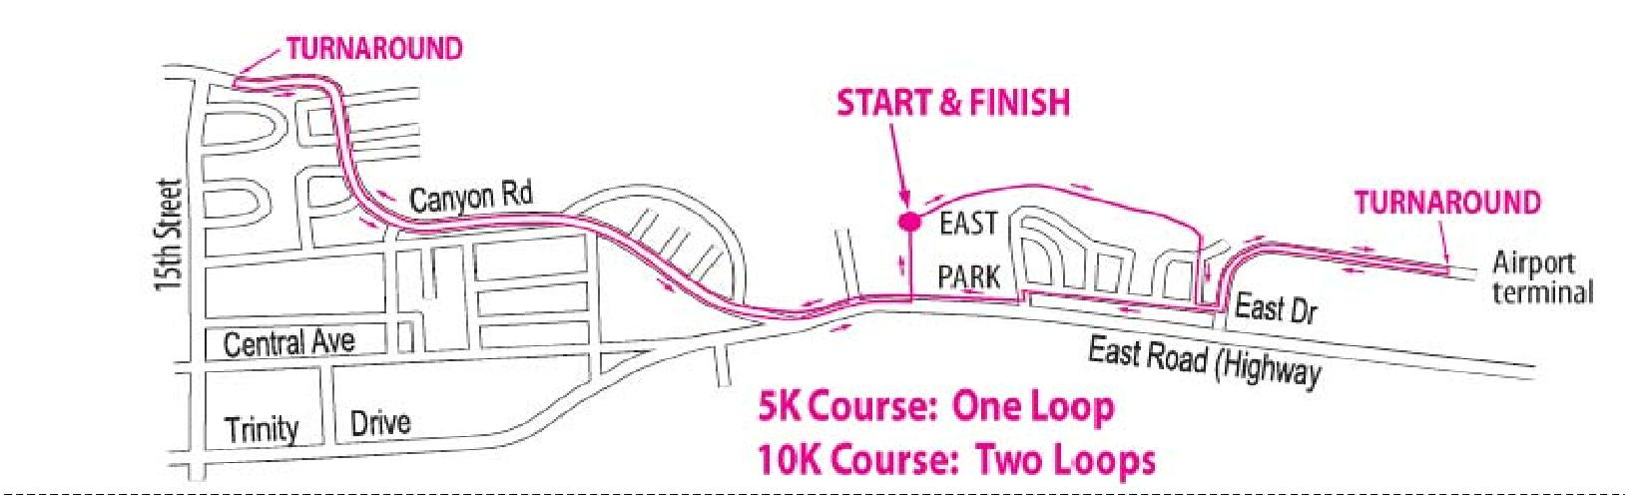

Cut and return this form with check to address below

Event: 5K_____ 10K_____ (Walkers Welcome)

Last Name_____________________________ First Name___________________ Sex: M___ F___

Address ___________________________________________City __________________________

State ____ Zip____________ Email ___________________________ Phone _________________

Age on Race Day _____ T-Shirt Size: S____ M____ L____ XL____ T-Shirts go to the first 50 registrants.

Payment: $25.00 payable to Hadassah. After April 1, 2017 and on race day, cost is $30.00.

Send check and this form to Hadassah, P.O. Box 26, Los Alamos, NM 87544. All donations and race proceeds will go to Hadassah for breast cancer research, education and treatment. For more information, call (505) 672-1639 or visit www.atomicrunners.com.

Waiver (must be signed)

I, the undersigned, intending to be legally bound, hereby for myself, my heirs, executors, and administrators, waive and release any and all rights and claims for damages I may have now and in the future against the County of Los Alamos, Hadassah, Run for Her Life, and any and all sponsors, cosponsors, agencies, or individuals and their representative successors, officers, agents, and assigns for any and all injuries, damages, and losses sustained and suffered by me as a result of my, or my child’s participation in this race. I understand that this release is binding upon my heirs, personal representatives, successors, and assigns. I verify that I am physically fit and have sufficiently trained for competition in this event and my physical condition has been verified by a licensed medical doctor. If, however, as a result of my participation in this race, I require medical attention, I hereby give my consent to the authorized medical personnel of this race to provide such medical care as is deemed necessary by such authorized personnel. I understand that in the event this race cannot be held as scheduled due to circumstances beyond control, the race is not liable to refund any money paid by me to participate. Further, I hereby grant full permission to any and all of the foregoing to use any photographs, videotapes, motion pictures, recordings, or any other record of this event for any legitimate purpose. I understand that the entry fee is non-refundable, and that the race numbers are not transferable. As a participating athlete, I certify that all information provided in this form is true and complete. I have read the foregoing and certify my agreement by my signature below.

Signature of Entrant: ______________________________________________________________
Signature of Parent or Guardian (if entrant is under the age of 18): ______________________________

