SECTION 40 0511

COMPRESSION FITTINGS ON COPPER AND STAINLESS STEEL TUBING

*************************************************************************************************************
LANL MASTER SPECIFICATION
When editing to suit project, author shall add job-specific requirements and delete only those portions that in no way apply to the activity (e.g., a component that does not apply). To seek a variance from applicable requirements, contact the ESM Mechanical POC.
When assembling a specification package, include applicable specifications from all Divisions, especially Division 1, General Requirements.
Information within “stars” is provided as guidance to the author responsible for revising the specification. Delete information within “stars” during editing.
This specification serves as a template. The specification was prepared by an organization operating under a quality assurance program that meets the requirements of 10 CFR 830 (suitable for ML-1 through ML-4 projects). Implementation of this specification requires modification to the specification to meet project-specific requirements. Responsibility for application of this specification to meet project-specific requirements lies with the organization modifying or implementing the specification. The organization modifying the specification shall apply a graded approach to quality assurance based on the management level designation of the project. When this specification is used with nuclear facilities subject to 10 CFR 830, modification to this specification must be performed by an individual or organization operating under a quality assurance program that meets the requirements of that CFR.
*************************************************************************************************************

PART 1 GENERAL

1.1 PURPOSE
- The purpose of this specification is to provide a safe and correct method for installation and remake of Swagelok fittings on stainless steel and copper instrument and process tubing up to a maximum OD of 1 inch.

B. Swagelok brand compression fittings are the available fittings through the LANL Just-In-Time contract. Other fitting manufacturers such as Parker, Autoclave Engineers, Hoke, Ham-Let, and Imperial Eastman may be used. Installation and remake of fittings other than Swagelok are not addressed in this document. Welded, Cajon VCR brand, and other fittings are not included in this document. Section 4 attachments are included in this specification.

Note: Other manufacturers of compression fittings will follow these general requirements. Specific makeup and installation instructions shall follow manufacturer’s written instructions. Use of compression fittings outside the scope of this specification shall be at the written direction of a technical person familiar with their application.

1.2 DESCRIPTION

A. Definitions
- Compression Fitting: A tube fitting consisting of two ferrules, a nut and the fitting body. The tubing is utilized to provide one of the sealing joints in the assembly.

2. Hex Flat: This describes 1/6 turn on a 6-sided Swagelok compression fitting or 60 degrees revolution with 360 degrees being one complete revolution.

B. Acronyms

1. ASME – American Society of Mechanical Engineers
- ASTM – American Society of Testing Materials
- B&PV – Boiler and Pressure Vessel
- DOT – Department of Transportation
- HVAC – Heating, Ventilation, and Air Conditioning
- ID – Inner Diameter
- LIR – Laboratory Implementation Requirements
- MAWP – Maximum Allowable Working Pressure
- OD – Outside Diameter
- SS – Stainless Steel
- TB – Technical Bulletin

C. References and Related Sections

1. ASME B31.1 – Power Piping
- ASME B31.3 – Process Piping
- ASME B31.9 – Building Services Piping
- LIR 402-1200-01 – Pressure, Vacuum, and Cryogenic Systems
- LIG 402-1200-02 – Inspection and Testing of Pressure Systems
- 22 0529 - Hangers and Support for Plumbing Piping and Equipment
- 22 0554, Identification for Plumbing, HVAC, and Fire Piping and Equipment
- 22 0813-- Testing Piping Systems

1.3 STORAGE AND HANDLING

A. Deliver tubing material and fittings to site in clean, degreased, and dry condition.

B. Maintain end seals and covers to physically protect parts and preserve cleanliness.

C. Remove end seals and covers only for cleaning, fabrication, erection, or inspection.

D. Exercise care in the handling and storage of materials and pre-fabrications to ensure that contamination by foreign material does not occur.

E. Do not drag tubing off trucks or rack (causes longitudinal scratches).

1.4 PREREQUISITES
- Installers of compression fittings shall be one-time trained on their assembly by the manufacturer or an authorized distributor, or through a formal LANL course for the following applications:
  - safety significant (SS), safety class (SC), and vital safety systems (VSS),
  - nuclear/radiological (glove boxes, wash downs, CAMs, etc.),
  - toxic systems, such as those contributing to a high or moderate facility categorization (e.g., beryllium),
  - intermediate and high pressure systems (defined here as 150 psi gas/1500 psi liquid and 3000 psi gas/5000 psi liquid max allowable operating pressures, respectively).

Acceptable Courses:
    - PS-13 Course 30831, Compression Fitting Assembly (future; approx 90 minutes at White Rock).
    - Course 19676, (approx 90 minutes at TA-60, taught through and largely for the SSS (KSL) by Albuquerque Valve and Fitting Co as needed; contact: Ronnie Tupin)
    - Swagelok Safety Seminar (approx 4 hours, taught by Albuquerque Valve and Fitting at their facility near the airport, Brad Crowson (505) 842-0213 or info@albuquerque.swagelok.com)
    - FWO Course EDS 20718, which was taught in the 2001-2003 timeframe by Bill Radzinski

B. Review drawings, details, manuals, and other material required for instrument or process tubing and fitting installation.
- C. Use the following guidelines during the performance of this specification:

1. Fitting Removal

a. If applicable, verify piping system has been properly isolated, drained, and tagged.
- b. Tube caps and fittings should not be used to bleed or vent any instrument/process lines at normal system pressures. This is an unsafe act that may result in serious injury or contamination.

D. When working with potentially contaminated systems, ensure catch bags, filters, or other mechanisms are used to contain any contaminants.

PART 2 PRODUCTS

2.1 EQUIPMENT REQUIRED
- Swagelok Tube Fitting Gap Inspection Gages for initial installation (See Attachment 4.4, Table 4.4-1)
- Special Tools
- Tube benders (with bend radius as required by Attachment 4.2, Table 4.2-1)
- Tube cutter (see Attachment 4.1)
- Tube deburring tool or equivalent
- Additional Equipment/Tools
- Applicable personal protective equipment
- 6-inch ruler
- Scribe (for marking fittings) or equivalent (indelible pen or felt tip marker – low chloride if on stainless steel)
- Open end wrenches (as required for application)
- Tubing, as applicable for work to be done
- Fittings and fitting components, as applicable for work to be done
  - TUBING MATERIAL
- *************************************************************************************************************

All selected tubing must be annealed with a Rockwell hardness of less than 80 (Rb 80) for success in fitting makeup. For guidance refer to Swagelok Tubing Data Catalog MS-01 and the following:

*************************************************************************************************************

1. Standards for Seamless Ferritic and Austentic Tubing and Piping: ASTM A213
- 2. Stainless Steel Tubing: ASTM A269, annealed, Type [304][316]
- 3. Seamless Copper Water Tube: ASTM B88, soft annealed, Type [K][L]
- 4. Seamless Bright Annealed Copper Tube: ASTM B68
- 5. Seamless Carbon Steel Tubing: ASTM A179, maximum hardness 72 HRb.
- 6. Seamless Copper Tube: ASTM B75, soft annealed

PART 3 EXECUTION

3.1 INSTALLATION

A. Follow Attachments 4.1 through 4.8 for proper installation, remake, and maintenance of Swagelok compression fittings.

3.2 PARTS REPLACEMENT

A. Do not connect, mix, or interchange parts (caps, plugs, ferrules, bodies, etc.) of tube fittings made by different manufacturers (such as Parker to Swagelok). Improper fitting seal, DAMAGE, or INJURIES may result.

B. Use all SS fittings and ferrules on SS tubing.

C. Use all brass fittings and ferrules on copper tubing.

3.3 POST INSTALLATION INSPECTION AND TESTING
- Inspection

1. Ensure lines are terminated correctly by performing visual continuity checks on each tubing run.

2. Ensure tubing and fittings are of the type and size specified.

3. Ensure tubing is free of wrinkles, flats, axial scratches, gouges, and humps.

4. Ensure tubing is properly supported and protected from damage.

5. Ensure threads are mostly or fully covered by fitting nut.

6. Check for proper pull up of the fitting with appropriate size no-go gage.

Note: Some fittings (e.g., bulkhead fittings) are not gageable.
- Leak Test

1. Test to determine the integrity of the component and related equipment to perform their intended functions. Pressure test all new piping and overall system, and any pressure system that has been modified or repaired, shall be pressure-tested before operating. Pressure test existing pressure systems (even if they have been previously tested) that, due to changes in mission or use, present significant hazards such as stored energy, toxicity, flammability, corrosiveness, or oxygen depletion, before operation. Testing must conform to the conditions of the relevant codes and standards (e.g., B&PV, B31, or DOT).

Note: Pressure and leak testing on systems in radiological service or containing hazardous materials require hazard control plans or activity hazard analysis. Systems greater than 15 PSIG require adherence to LIR 402-1200-01.

2. On pressure systems, perform a pressure test in accordance with an appropriate ASME B&PV Code, or appropriate section of B31 piping codes (see LIR 402-1200-01). Testing per Section 22 0813, Testing Piping Systems.

3. Systems under 15 PSIG may be pressure tested in accordance with appropriate ASME B31 section or using LIG 402-1200-02 – Inspection and Testing of Pressure Systems as guidance.

PART 4 ATTACHMENTS

4.1 Tube Cutting

4.2 Tube Bending

4.3 Tubing Installation

4.4 Swagelok Fitting Initial Installation

4.5 Tube Fitting Tightening Due to Leaking Fitting

4.6 Tube Fitting Removal and Reconnection
  - Tube Cap Installation
  - Tube Cap Reinstallation
end of section

*************************************************************************

Do not delete the following reference information:
*************************************************************************

for lanl use only

This project specification is based on LANL Master Specification 40 0511 Rev. 0, dated January 6, 2006.

Attachment 4.1
Tube Cutting

CAUTION: • When cutting, ensure tubing does not get hot. Heat hardening of tubing may
cause fitting failure.

• Tube cutters used for SS up to 1” OD must be specially designed to avoid work hardening.

• Due to the possibility of introducing foreign particles internal to tubing, ensure tubing is clean and deburred after cuts (hacksaw use is highly discouraged).

NOTE: Tubing shall be cut using tools designed and maintained (sharp cutting surfaces)
specifically for that purpose.

4.1.1 Tube Cutters

- Using tube cutters, cut tubing squarely with gradually applied force. Use 1/8 turn of cutter knob for every two revolutions on steel or stainless steel. Use 1/8 turn of cutter knob for each revolution when cutting copper tubing.

- Deburr ID of tubing.

- Clean as necessary.

4.1.2 Hacksaw (hacksaw use is highly discouraged)

- When using a hacksaw to cut tubing, use tube sawing guide instead of a vise to ensure a square cut and to keep tubing from flattening out.

- Hacksaw blade should have 24 teeth per inch minimum.

- For proper entry into fitting and to prevent system contamination and/or restricted flow, deburr both ID and OD of tubing.

- Clean as necessary.

Attachment 4.2
Tube Bending

NOTES: 1. Tubing minimum bending radius shall be based on the applicable tubing OD (tube fittings shall be used whenever smaller bending radii are required).
2. Tube bending will result in wall thinning and the need to derate the tubing design pressure per ASME (e.g., ANSI/ASME B31.9 Section 102.4.5).

4.2.1 Use table 4.2-1 to determine minimum tubing bend radius.

Table 4.2-1 Minimum Bending Radius for Tubing (requires derating)

For Tube Bend
≤ 180⁰
Tubing  OD  (inch) | Min Bend  Radius  (inch) | Calculated  Bend Radius  (diameters) | Resulting Wall Thinning  (%)
1/8 | 3/8 | 3 | 22
1/4 | 9/16 | 2.25 | 31
1/4 | 3/4 | 3 | 22
3/8 | 15/16 | 2.5 | 27
1/2 | 1-1/2 | 3 | 22
5/8 | 2-1/4 | 3.6 | 19
3/4 | 3 | 4 | 17
1 | 4 | 4 | 17

NOTE: 1. All tube bends shall be made using tools designed specifically for that purpose. Caution shall be exercised to ensure a smooth, even bend with minimal flattening, wrinkles, humps, or other damage to tubing.

2. Tube benders vary, but requirements for minimum bend radius shall be met.

3. Actual bend radius can be greater than required minimum.

4.2.2 Select tube bender that meets the minimum bend radius requirements from Step 4.2.1 (Table 4.2-1).

4.2.3 Bend tubing as follows:
A. Ensure even bends with no flattening or other damage to tubing.

B. Bend tubing so that deformed section at bend does not enter fitting. See dimension L on Figure 4.2-1 and Table 4.2-2.
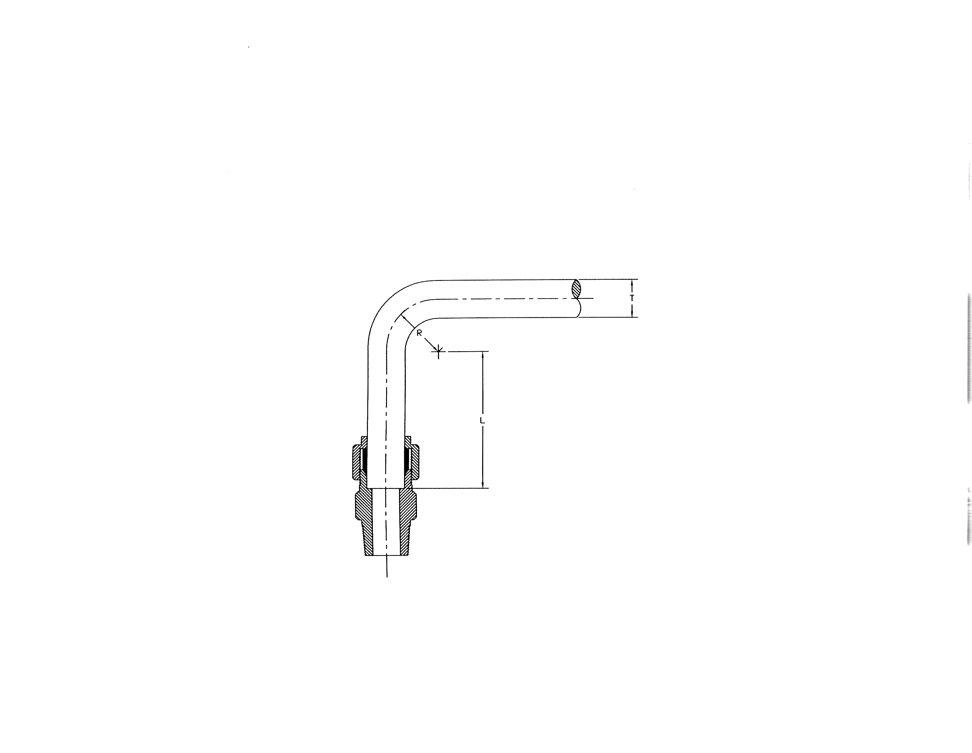
Figure 4.2-1 Guidance for Determining Length Between Tube Bend and Fitting

Table 4.2-2 Determining Length Between Tube Bend and Fitting
T (inch) Tubing OD |  | 1/8 | 1/4 | 3/8 | 1/2 | 5/8 | 3/4 | 1
L (inch)  Length of  Straight  Tube | Recommended | 3/4 | 13/16 | 15/16 | 1 3/16 | 1 1/4 | 1 1/4 | 1 1/2
L (inch)  Length of  Straight  Tube | Absolute  Minimum | 5/8 | 11/16 | 3/4 | 1 | 1 1/6 | 1 1/16 | 1 5/16

CAUTION: Do not spring tubing into position in fitting as this can result in excessive stress on
tubing and connections leading to leakage.

C. Tube line fabrication (bend angles and measured lengths) must be accurate so that the tube end easily enters the fitting in proper alignment.

- When a section of bent tubing is being connected, ensure that tubing is in proper alignment with fitting before tightening.
- Use bends where practical instead of fittings.

4.2.4 Verify and document based on applicable Project Quality Management Plan.

Attachment 4.3
Tubing Installation

4.3.1 Flush or blow down tubing and fitting(s), where practical.

4.3.2 Ensure that visible internal surfaces of tubing are clean of any foreign matter. Remove all filings, chips, and grit before attachment of fittings. Cover ends until final installation.

4.3.3 Use related attachments with this one as necessary.
A. Tube Cutting (Attachment 4.1)
B. Tube Bending (Attachment 4.2)
C. Swagelok Fitting Installation (Attachment 4.4)

4.3.4 Plan tubing layout to ensure:
    - Tubing does not block access to doors, bolts and equipment that needs to be accessed for maintenance.
    - When attaching tubing to an item that may occasionally be removed for repair or maintenance, ensure method of connecting and running tubing allows easy removal.
    - Ensure tubing is kept clear of controls and does not impede operator’s access to controls.
D. If tubing is run in an area that will expose it to damage, e.g., being stepped on or used as a hand hold, review with supervisor or technical support for need/method to protect tubing.
- Ensure tubing is appropriately supported. Refer to LANL Specification Section 22 0529 Hangers and Supports for Plumbing Piping and Equipment.
- Ensure valves or other devices that require torque to be executed in their operation are mounted so that a twisting movement is not applied to tubing. Normally this would require valves or other devices to be mounted using a bracket to hold it in place.
- If possible, gang tubing vertically rather than horizontally to avoid collection of dirt, corrosives, and contaminants.
- Ensure fittings are staggered and offset when making multiple runs to provide easier installation and conserve space.
- Verify slope requirements are met per appropriate design standards.

NOTE: Straight runs between two fixed fittings should be avoided. This does not allow for expansion and or for tubing to be properly bottomed in fitting when being made up.

J. If necessary, use expansion loops in tubing to allow for thermal growth.

K. If necessary, make layout sketch of tubing runs by measuring distances with a flexible steel rule. Some suggestions to consider:
      - Consult fitting vendor catalog to determine distance to end point of tubing. (See Attachment 4.2 on bending tubing)
      - Measure all dimensions to and from centerline of tubing.
      - For clearances, it is necessary to allow for one-half tubing OD to clear obstructions to prevent rubbing.
      - Tube bends can be measured square and excess tubing trimmed from end after bending. For more accurate tube length measurement, length of tubing in a bend can be calculated using Table 4.3-1 and the equation below:

Table 4.3-1 Bend Angle Cross Reference To Bend Factor
Degrees of Bend | 30⁰ | 45⁰ | 60⁰ | 90⁰ | 180⁰
Bend Factor | 0.52 | 0.78 | 1.04 | 1.57 | 3.14

Required Tube Length = Bend Bend

X

Factor Radius

NOTE: Example: For a 90⁰ bend with a bend radius of 2 inches:

Required Tube Length = (1.57) x (2 inches) = 3.14 inches

    - Label piping system. Refer to Section 22 0554, Identification for Plumbing, HVAC, and Fire Piping and Equipment.
    - Verify and document based on applicable Project Quality Management Plan.

Attachment 4.4

Swagelok Fitting Initial Installation

NOTE: When using compression fittings other than Swagelok, the manufacturer’s installation instructions shall be furnished by the fitting supplier.

4.4.1 Refer to the following for:

- Tube Cutting (Attachment 4.1)
- Tube Bending (Attachment 4.2)

4.4.2 Flush or blow down tubing / fitting(s), where practical.

4.4.3 Ensure that visible internal and external surfaces of tubing and fitting(s) are clean of any
foreign matter.

NOTE: Tubing surface finish is very important to proper sealing. Tubing with any depression, scratch, raised portion, or other surface defect will be difficult to seal.

4.4.4 Ensure:

- No axial scratches along tubing where ferrule seats
- Ferrule(s) are not scratched or deformed
- Fittings components are of proper type
- Parts are not mixed or interchanged with another manufacturer
- No damaged threads on fitting bodies and nuts

NOTES: • The small tapered end of ferrule goes into fitting body.
• Swagelok fittings have a two piece ferrule: front ferrule (large piece) and back
ferrule (small piece).
• Do not use Teflon tape on tube end of fitting body threads. A small amount of low- chloride lubricant on stainless steel threads can be used to minimize galling (do not get inside the process; (Swagelok Silver- or High Purity-Goop are acceptable).

4.4.5 Makeup nut and ferrule(s) on tubing. See Figure 4.4-1.
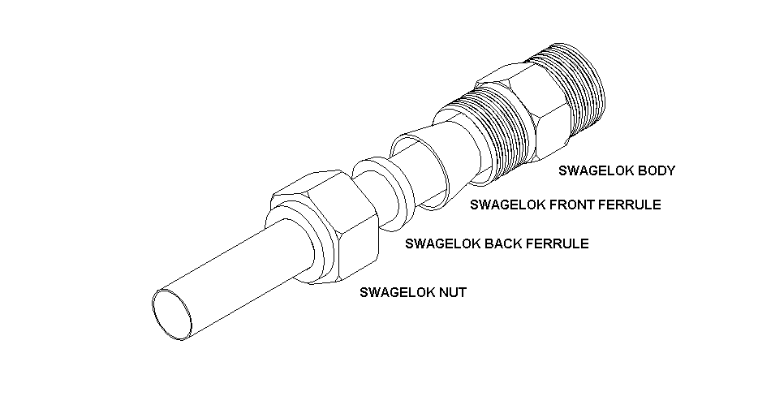
Figure 4.4-1 Swagelok Fitting Exploded View Showing Ferrules Orientation

NOTE: Fittings are not normally disassembled prior to use as contaminants may enter fitting or ferrules may be lost.

4.4.6 Align tubing with fitting so that tubing end easily enters fitting in proper alignment.

    - Insert tubing end until it bottoms against shoulder in fitting body. While holding tube end against shoulder in fitting body, tighten nut finger tight. This is necessary to prevent movement of the tube while the nut forces the ferrule to grip the tube and to seal through any minor imperfections that may exist on the outside of the surface.

NOTE: • If unexpected resistance is felt when threading nut to finger tight, then fitting should be cleaned or replaced, as applicable.

• Do not force an improperly fitted tube line into the fittings. If tubing is oval or will not easily fit through fitting nuts, ferrules, and bodies, do not force tubing into fittings.

• Tightening fittings finger tight means manually, with no tools.

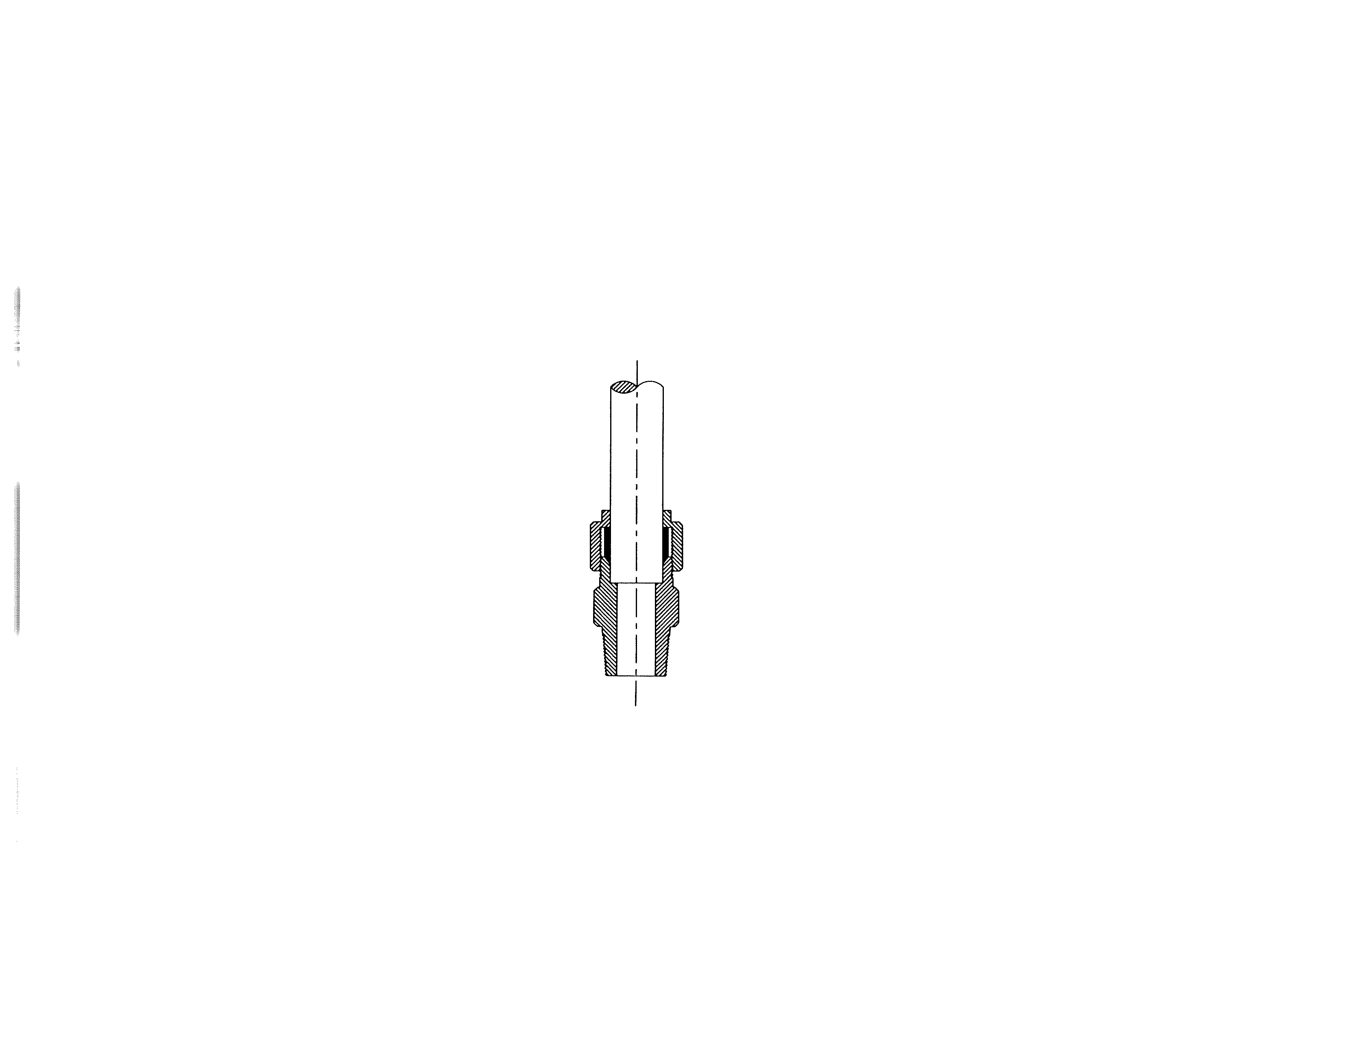

Figure 4.4-2 Swagelok Fitting Cutaway View

4.4.8 Scribe fitting at 6 o’clock position. Use indelible pen or felt tip marker. If desired, fitting body may also be marked temporarily to verify number of turns in the following step.

NOTE: When scribing nut and fitting body on fittings where scribe reference on body may be used for more than one nut (e.g., union, elbow, etc.), ensure that scribe marks relating to each nut are distinguishable.

4.4.9 While holding fitting body steady with backup wrench:
- For tubing OD ≥ 1/4 inch: Tighten nut 1-1/4 turns (as shown in Figure 4.4-3 below left) to swage ferrule. (Nut mark should be at 9 o’clock position).

B. For tubing OD < 1/4 inch: Tighten nut 3/4 turn (as shown in Figure 4.4-4 below right) to 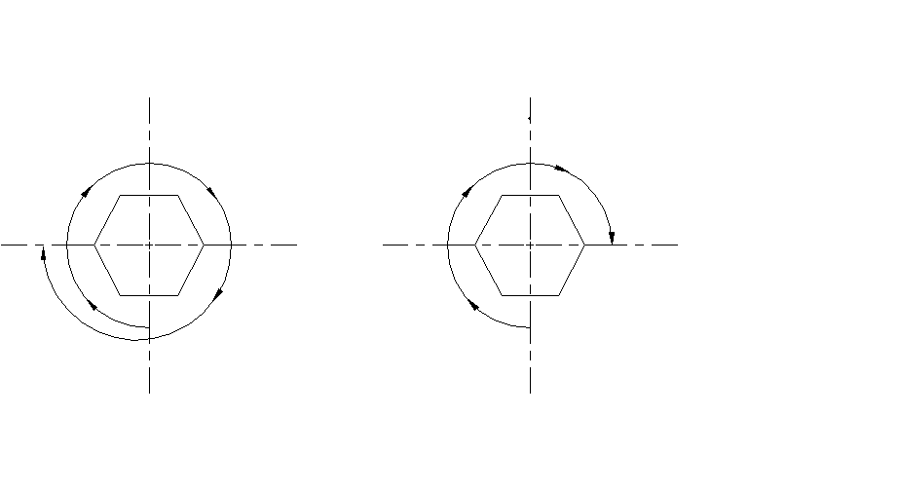swage ferrule. (Nut mark should be at 3 o’clock position).
Figure 4.4-3 Tightening Nut 1 1/4 Turns Figure 4.4.-4 Tightening Nut 3/4 Turn
(for tubing OD ≥ 1/4 inch) (for tubing OD < 1/4 inch)

CAUTION: • Never permit the fitting body to rotate during tube end make-up. Two wrenches must be used. Assemble port connectors to components first and hold with wrench while making up the tube joint. All types of union bodies must be held while each of the tube ends is makeup.
• Never attempt to makeup by torque or feel. Always turn the nut the prescribed amount (listed above) regardless of torque required.

NOTE: • A gap inspection gage is used with Swagelok fittings to verify proper swaging and pull up.
- Gap inspection gages should be used unless physical makeup of fitting prevents their use.
- Gap inspection gage is not required on jam nut of Bulkhead Union Fitting or other fittings without shoulders. Step 4.4.10 provides alternative inspection method.
- During initial installation using gap inspection gage, Swagelok fittings do not require disassembly and visual inspection if made up to manufacturer’s instructions.

Table 4.4-1 Swagelok Gap Double-Ended Inspection Gages
Tubing OD (inch) | 1/8 | 1/4 | 5/16 | 3/8 | 1/2 | 5/8 | 3/4 | 1
Swagelok Gage Series | 200 | 400 | 500 | 600 | 810 | 1010 | 1210 | 1610

NOTE: Only the following Swagelok Gap Inspection Gage ends are to be used in this procedure:

• For tubing OD ≥ 1/4 in.: Use 1-1/4 TURNS FROM FINGER TIGHT end

• For tubing OD < 1/4 in.: Use 3/4 TURNS FROM FINGER TIGHT end

C. Attempt to insert gap inspection gage between fitting nut and body hex.
- For tubing OD ≥ 1/4 inch: Use 1-1/4 TURNS from FINGER TIGHT end
- For tubing OD < 1/4 inch: Use 3/4 TURN from FINGER TIGHT end
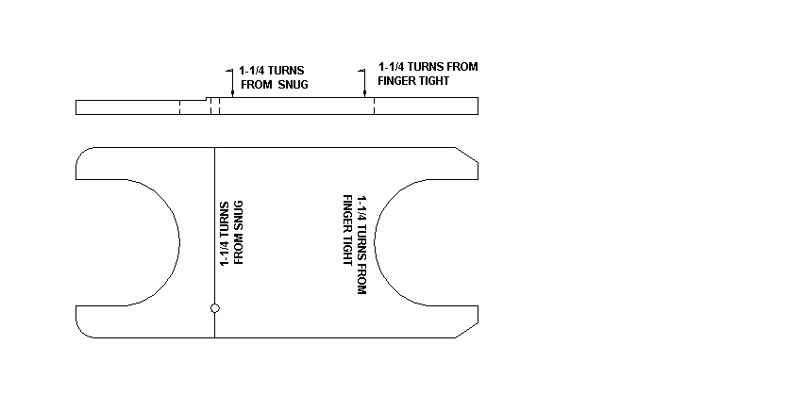
Figure 4.4-5 Typical Swagelok Gap Gage

CAUTION: Do not tighten fittings with gap gage in place.

NOTE: • If gap inspection gage fits between nut and body hex, fitting is not sufficiently tightened.
• If any tubing/fitting makeup is found to be questionable, then remake, replace, or repair as necessary.

- If using Swagelok MS-IG 468 (multiple size) no-go gage, measure from finger tight.

D. If gap inspection gage fits between nut and body hex, tighten in 1/4 hex flat increments until gage does NOT fit into space. DO NOT tighten more than 2 hex flats (1/3 turn) past:
- For tubing OD ≥ 1/4 inch: 9 o’clock position (refer to Figure 4.4-3)
- For tubing OD < 1/4 inch: 3 o’clock position (refer to Figure 4.4-4)

E. When gap inspection gage will NOT fit between nut and body hex, installation of fitting is correct.
4.4.10 If a gap inspection tool cannot be used and personnel safety depends on proper makeup, then check for proper fitting makeup as follows:

NOTE: Scribe mark is reference point used in subsequent fitting tightening.

- Scribe fitting and nut in their final position.

CAUTION: If tubing end does not sufficiently extend past ferrule, improper fitting seal may result.

- Remove nut , disassemble fitting, and visually inspect for:

- Ferrule(s) orientation is correct.
- Ferrule(s) swaged.
- Tubing extends past end of ferrule to ensure tubing bottoms out in fitting.
- If end tubing is visible, verify tube end is properly cut and free of burrs.

NOTE: • It is recommended that Swagelok fittings not be tightened > 1/6 to 1/4 turn past scribe mark.

• When reconnecting fitting, a slight increase in resistance (torque rise) will be felt indicating ferrule is being resprung to its original position.

- Fitting end plugs and port connections require only 1/4” turn from finger tight makeup in all sizes. Tightening fitting finger tight normally means manually, with no tools. Sizes 1/16 to 3/16 can be damaged (tube snapped or cut) by over tightening.

- Reconnect nut as follows:

1. While ensuring tubing is aligned and bottomed against shoulder in fitting body, tighten nut finger tight.

2. Tighten nut to its original position as indicated by scribe marks, then snug slightly (with wrench), typically 1/6 to 1/4 turn maximum.

    - Verify fitting(s) makeup completed and document based on applicable Project Quality Management Plan.

Attachment 4.5
Tube Fitting Tightening Due to Leaking Fitting

WARNING: • Before tightening fittings, system must be depressurized.

NOTES:
• It is recommended that fittings not be tightened more than 1/6 to 1/4 turn past the scribe mark.
• If fitting is not scribed, tightening may be done using good craft practice.

4.5.1 If fitting leaks, tighten fitting in increments of 1/4 hex flat until leak stops.

4.5.2 If fitting still leaks, evaluate as follows:

- If practical, take fitting apart and examine for scratches on tubing or ferrule, damaged threads, or improper tubing alignment. If no problems are found, or replacement is not required, reconnect per applicable steps of appropriate attachment.

- Determine if fitting should be replaced. Take necessary action to replace fitting.

Attachment 4.6
Tube Fitting Removal and Reconnection

4.6.1 Fitting Removal (system must be depressurized)

A. Inspect fitting for previously scribed marks.

B. If fitting is not scribed, before disconnecting, perform as follows:

1. Inspect fitting for leaks and indication of leaking.

2. Inspect fitting for looseness (by hand).

3. If leaks or looseness are noted:

a. Evaluate the need to replace fitting.

b. If necessary, replace fitting per applicable attachment of this specification.

NOTE: • When scribing nut and fitting body on fittings where scribe reference on body may be used for more than one nut (e.g., union, elbow, etc.), scribe marks relating to each nut are to be distinguishable.

• For maximum number of remakes, mark the fitting and nut before disassembly to prevent over tightening caused by guesswork.

4. If no leaks or looseness are noted, scribe fitting. Use this mark as original installation scribe mark.

WARNING: In all applications where root or instrument isolation valves are installed, tube caps or fittings can be used to release trapped pressure in instrument lines, after the root valve or instrument isolation valve(s) are closed. For other applications, Step 1.5.B of this specification’s main section provides guidance.

5. Remove fitting. Ensure proper cleanliness level is maintained.

4.6.2 Fitting Reconnection

A. If both ends of tubing/fitting(s) are open, flush or blow down tubing/fitting(s), where practical.

B. Verify that visible internal and external surfaces of tubing and fitting(s) are clean of any foreign matter.

C. Check fittings visually for condition of threads, ferrule, and tubing. If fitting is damaged, initiate action to replace.

CAUTION: If Safety Installation Collar was installed on Swagelok fitting, remove it before
reconnection.

NOTE: Safety Installation Collar may have been installed with Swagelok fittings on large OD tubing to verify proper swaging.

D. Insert assembly into fitting until ferrule seats into fitting.

NOTE: If resistance is felt when threading nut to finger tight, fitting should be cleaned or
replaced, as applicable.

E. Thread nut onto body finger tight and tighten to original scribe mark.

NOTE: • A slight torque rise will be felt indicating ferrule is being resprung to its original
position.

- It is recommended that fittings NOT be tightened more than 1/6 to 1/4 turn past scribe mark.

F. If connecting swaged ferrule/tubing/nut assembly with new fitting body (where fitting body will not have scribe mark):

1. Tighten nut until rise in torque is felt.

2. Scribe fitting body (align with nut scribe mark).

3. Snug fitting slightly with wrench.

- G. If fitting body and nut are scribed:

1. Retighten nut by hand.

2. With two wrenches, tighten nut to its original position as indicated by scribe marks. A noticeable increase in mechanical resistance will be felt indicating the original position. Then tighten 1/6 to 1/4 turn with wrench.

3. If torque rise is NOT felt, tighten nut an additional 1/12 turn (1/2 hex flat).

H. Verify and document based on applicable Project Quality Management Plan.

Attachment 4.7
Tube Cap Installation

CAUTION: Connecting, mixing or interchanging parts (caps, plugs, ferrules, bodies, etc.) with tube fittings made by different manufacturers (such as Parker to Swagelok) may cause improper fitting seal, damage, or injuries.

4.7.1 Inspect for damaged threads on fitting bodies and nuts.

4.7.2 Verify that visible internal and external surfaces of tubing and fitting(s) are clean of any foreign matter.

NOTE: If resistance is felt when threading nut to finger tight, cap or fitting should be cleaned or replaced, as applicable.

4.7.3 While holding fitting body with backup wrench, tighten tube cap finger tight.

4.7.4 Using wrench, tighten tube cap 1/4 turn (1 1/2 hex flats) to seat tube cap.

4.7.5 Scribe tube cap in final position

4.7.6 If tube cap leaks

A. Mark tube cap and fitting.

B. Tighten tube cap an additional 1/2 hex flat. Repeat as necessary in 1/2
hex flat increments up to limit of 2 hex flats (1/3 turn).

C. Scribe tube cap in final position.

4.7.7 Verify and document based on applicable Project Quality Management Plan.

Attachment 4.8
Tube Cap Reinstallation

4.8.1 Inspect for damaged threads on fitting bodies and nuts.

4.8.2 Verify that visible internal surfaces of tubing and fitting(s) are clean of any foreign matter.

NOTE: If resistance is felt when threading nut to finger tight, cap or fitting should be cleaned or replaced, as applicable.

4.8.3 While holding fitting body with backup wrench, tighten tube cap finger tight.

4.8.4. Using wrench, tighten tube cap to original position.

4.8.5 If tube cap is not leaking, go to Step 4.8.7.

4.8.6 If tube cap leaks:

A. Mark tube cap and fitting.

B. Tighten tube cap an additional 1/2 hex flat. Repeat as necessary in 1/2 hex flat
increments up to limit of 2 hex flats (1/3 turn).

4.8.7 Verify and document based on applicable Project Quality Management Plan.

